Name __________________

Weather Trends
Using the weather data found at www.weatherbug.com, answer the following questions.

- Go to www.weatherbug.com
- Click on Forecast and then Daily
- Over a one-week period (the next 7 days), find out the fraction of days with the type of weather listed in the table.
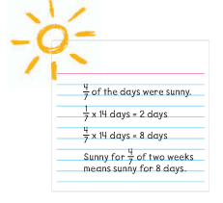
Use the example above to help you...

Type of weather (day) | Fraction of days for one week | # of days that correspond to a two week period
Sunny
Mostly Sunny
Partly Sunny
Rain showers
Mostly cloudy
Partly cloudy

Complete the table for the night time weather.

Type of weather (night) | Fraction of days for one week (7 days) | # of days that correspond to a two week period
clear
Mostly clear
Mostly cloudy
Partly cloudy
Rain showers
Cloudy

Now click on the hourly weather for today’s date and complete the table below.

Type of weather | Fraction of hours in the day with this weather | # of hours that correspond to two days (48 hours)
Sunny
Mostly sunny
Clear
Mostly clear
Cloudy
Mostly cloudy
Rain showers

**Write and solve a fraction multiplication word problem using your weather data.

